Final Project Report

Implementation of Deep Learning Approach for detection of Plant Leaf Diseases



Project Supervisor
Dr. Saima Munawar

Submitted By

Group Id: S2202618A5
Ali Fraz BS180407311

Software Projects & Research Section,
Department of Computer Sciences,
Virtual University of Pakistan

CERTIFICATE

This is to certify that Mr. Ali Fraz (BS180407311) have worked on and completed their Software Project at Software & Research Projects Section, Department of Computer Sciences, Virtual University of Pakistan in partial fulfillment of the requirement for the degree of BS in Computer Sciences under my guidance and supervision.

In our opinion, it is satisfactory and up to the mark and therefore fulfills the requirements of BS in Computer Sciences.

Supervisor / Internal Examiner

Dr. Saima Munawar
Supervisor,
Software Projects & Research Section,
Department of Computer Sciences
Virtual University of Pakistan

___________________
(Signature)

External Examiner/Subject Specialist
<<External Supervisor Name>>

___________________
(Signature)

Accepted By:
_____________
(For office use)

EXORDIUM

In the name of Allah, the Compassionate, the Merciful.

Praise be to Allah, Lord of Creation,
The Compassionate, the Merciful,
King of Judgment-day!

You alone we worship, and to You alone we pray for help,
Guide us to the straight path

The path of those who You have favored,

Not of those who have incurred Your wrath,
Nor of those who have gone astray.

DEDICATION

To

The Last Prophet
Hazrat Muhammad (ﷺ)

All words dedicated with respect to

LOVING PARENTS
Whose love and prays always accompanies like a shining star whenever was in darkness.

ACKNOWLEDGEMENT

I would like to express deep thanks and wholehearted thanks to my respected teacher Dr. Saima Munawar for her valuable guidance, suggestions and encouragement in completing the project successfully

PREFACE

The idea behind the development of this project is to develop a shape recognition AI based machine learning based application development using machine learning technique. After development of the system then system will provide us to identification any shape which belong trained shapes. For this purpose we are using Deep learning approaches which is use to classification of multiple classes and disease identification of plants. For this we create dataset using paint software of windows. The developed system is very useful for the identification plants diseases easily.
TABLE OF CONTENTS

CHAPTER NO. 1
gathering & Analyzing info 10

1.1 Introduction
1.2 purpose
1.3 scope
1.4 definitions, acronyms and abbreviations
1.5 Project requirements
1.5.1 Functional Requirements

1.5.2 Non-Functional Requirements

1.6 use cases and usage scenarios
1.6.1 Use Case Diagrams

1.6.2 Usage Scenarios

1.7 Development Methodology
1.7.1 Chosen Methodology

1.7.2 Reasons for Chosen Methodology
1.7.3 Work Plan (Gantt chart)
1.7.4 Project Schedule (Submission Calendar)

CHAPTER NO. 2
designing the project 12

2.1 Introduction

2.2 Architectural Representation (Architecture Diagram)

2.3 Dynamic Model: Sequence Diagrams

2.4 Object Model/Logical Model: Class Diagram

2.5 Graphical User Interfaces

Chapter no.3
DEvelopment 13
3.1 Introduction

3.2 Dataset

3.3 Features Extraction

3.3.1 Local Binary Pattern Technique

    - Histogram Oriented Gradient

    - Gray level co-occurrence matrix(GLcM)

3.4 Classification Algorithm

3.4.1 Sequential Architecture Deep Learning Model

3.5 Training
3.6 Testing

3.7 Graphical User Interface

CHAPTER 1
Gathering & Analyzing Info

  - Introduction
Agriculture is one field which has a high impact on life and economic status of human beings. Improper management leads to loss in agricultural products. Diseases are detrimental to the plant’s health which in turn affects its growth. To ensure minimal loss to the cultivated crop, it is crucial to supervise its growth. Convolutional Neural Network is a class of Deep learning used majorly for image classification, other mainstream tasks such as image segmentation and signal processing. The main aim of the proposed work is to find a solution to the problem of 8 different classes of plant diseases detection using the simplest approach while making use of minimal computing resources to achieve better results compared to the traditional models. Sequential training model is deployed for detection and classification of plant diseases. Neural network models employ automatic feature extraction to aid in the classification of the input image into respective disease classes. This proposed system has achieved an average accuracy of 99% indicating the feasibility of the
  - purpose
Before Building any system it should be clear that is the system is beneficial for the owner as well as user. So this system is absolutely beneficial. The main purpose of the system is to classification of multiple different shapes and identification of these shapes using advance intelligence system. So for this purpose we develop this application. If we use this application commercially it is very useful as well and we can sort many shape recognition problem using this application.

  - scope
Agriculture is a sector which has a huge impact on life and economic stature of humans. Agriculture proves to be a primary source of livelihood, for about 58% of India’s population. India ranks second globally in terms of farm yields. It was reported in the year 2018 that agriculture opened the doors of employment for more than 50℅ of the employees, hence contributing to 18–20% to country's GDP. Pakistan has thus proven to be one of the leading nations in term of agricultural yield and productivity. With this majority of population rely on agriculture, it is very crucial to recognize the problems faced in this sector. There are a numerous of problems that the agriculture field faces such as inefficient farming strategies and techniques, inadequate use of compost, manures and fertilizers, insufficient water supply, various diseases attack on plants and so on. Diseases are exceedingly harmful to the well-being of plants which in turn influence its growth. The attack of these numerous types of diseases on plants results in a huge loss in the yield performance in terms of quality as well as quantity. Affected by diseases add up to for about 20-30% of the entire crop deprivation. Thus, recognizing diseases in plant becomes very crucial in order to avoid any massive losses in production, performance and in the amount of the agricultural outcome. Since manual recognition is extremely time consuming and more prone to inaccuracy, leading to wrong treatment. The recent development in technology, and this evolution has made it feasible and possible thus made its way for plant disease detection and identification and contribute to provide better treatment for plants in case of any plant having diseased conditions. The proposed system of recognition of plant leaf diseases focuses on 14 varieties of plants which include apple, blueberry, cherry, corn, grape, orange, peach, pepper, potato, raspberry, soybean, squash, strawberry and tomato. This system is built on concepts of Deep Learning- Convolutional neural networks (CNN) is posted for formation of a statistical model that is executed on the input image and transforms the input to classify output tags.

1.4 definitions, acronyms and abbreviations

1.5 Project requirements
1.5.1 Functional Requirements
Plant village leaf dataset download. Which consist of almost 1300 images different sizes belongs to 38 different classes. We consider just two 8 classes of Apple and Corn diseases. Divide the dataset into 80% training set to train a model and 20% testing set to test the trained model. Extract features from the images using different built-in functions etc. identification of diseases and classification of disease is done by deep learning approach Sequential Architecture. Train Sequential model using the training dataset. Test Sequential model using the test dataset. The system should have the capability to test the complete testing set and then generate the accuracy report for all the diseases. The system should also have the capability to test a single image. All work is done on Google colab model training and pycharm for GUI creation.
1.5.2 Non-Functional Requirements
Safety Requirements
Administration need to proper backup of data so that in case of any problem on the hosting server data will not be lost. In case of power failure the system should recover to a consistent state and the system should be able to recover the lost data.
Performance Requirements
This software is sophisticated and perform the activities is very well. Response time for a transaction: average 5 seconds, maximum 10 seconds.
Reliability
Availability: Application shall be available 7/24. Maintenance shall be done 3:00-6:00 am. When there is no internet connection user can only choose push notification mode being deprived of immediate result.
Security Requirements
Only authorized user should be able to login to system and access the information or data. System should verify the identity of the user before allowing access to the accounts information. System should be securing from any unauthorized malicious programs e.g. Viruses, Trojans, spy wares, Dos, etc. and hijack attacks.
1.6 use cases and usage scenarios
1.6.1 Use Case Diagrams

1.6.2 Usage Scenarios

Data Load
Use case | Data load
Use case id | 1
Actor | Admin
Description | Admin upload the training dataset

Feature Extraction
Use case | Feature extraction
Use case id | 2
Actor | Admin
Description | Admin extract the features of given dataset
Training and Classification
Use case | Training and classification
Use case id | 3
Actor | Admin
Description | Train and Classify the model using extracted features

Testing
Use case | Testing
Use case id | 4
Actor | Admin
Description | In this step test the model using test dataset

Testing Single Image
Use case | Testing single image
Use case id | 5
Actor | Admin and user
Description | Admin and user can use the application using single image

  - Development Methodology
Spiral Methodology, Prototyping Methodology, Waterfall Methodology
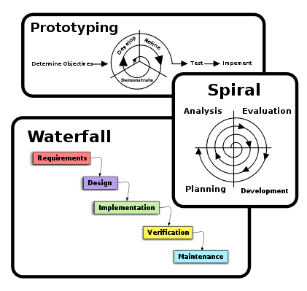

Spiral Model

The spiral model is a risk-driven process model generator for software projects. Based on the unique risk patterns of a given project, the spiral model guides a team to adopt elements of one or more process models, such as incremental, waterfall, or evolutionary prototyping.
Prototyping Model

The Prototyping Model is a systems development method (SDM) in which a prototype(an early approximation of a final system or product) is built, tested, and then reworked as necessary until an acceptable prototype is finally achieved from which the complete system or product can now be developed. This model works best in scenarios where not all of the project requirements are known in detail ahead of time. It is an iterative, trial-and-error process that takes place between the developers and the users.
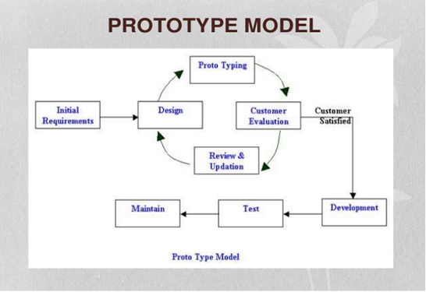

Waterfall Model

The waterfall model is a sequential (non-iterative) design process, used in software development processes, in which progress is seen as flowing steadily downwards (like a waterfall) through the phases of conception, initiation, analysis, design, construction, testing, production/implementation and maintenance. Despite the development of new software development process models, the Waterfall method is still the dominant process model with over a third of software developers still using it.
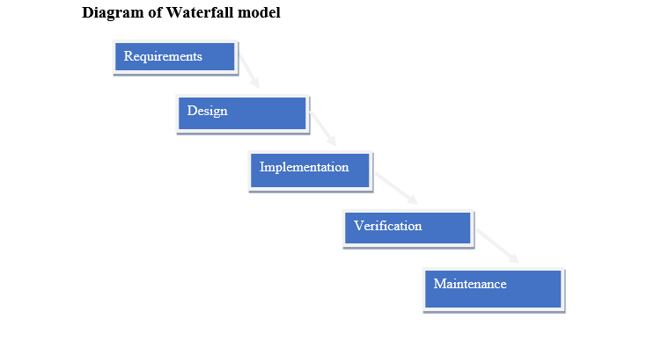
1.7.1 Chosen Methodology

I have been studied all the methodologies and then I choose the Virtual University Model for my project. University also guides us that you must use Virtual University Model for project and this model full fills all the project requirements. So I chose VU Model. The detail of VU Model is as under.
- System Requirement Specification (SRS)
- Design phase.
- Test phase 1
- Test phase 2
- Development
- Final Report
- Presentation and viva
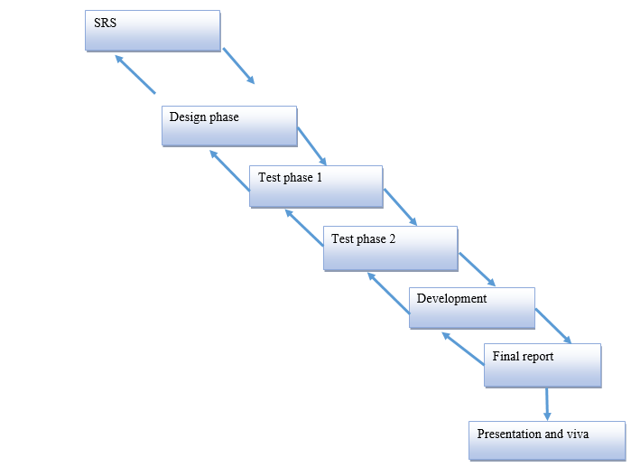

1.7.2 Reasons for Chosen Methodology
I choose VU model for my project. Reasons for adopting this methodology is as under.
- Virtual University of Pakistan guides us that you must select VU Model for project.
- Only VU Model full fills all the requirements of my project.
- VU Model is the combination of Waterfall and Spiral methodologies. One feature of waterfall methodology is the sequence of steps that we take in our methodology and one feature of spiral methodology is to go previous steps. This feature also we include in our methodology.
1.7.3 Work Plan (Gantt chart)

Arranging is imperative piece of begin of any project on the grounds that on the off chance that it is arranged in a decent way then it will make an effective and important project. Graphical representation of time taken to finish the project will likewise be appeared.

1.7.4 Project Schedule (Submission Calendar)

Plan consists of following stages.
- Team structure
- Detailed project schedule

Team Structure

The project Shape classification using SEQUENTIAL ARCHITECTURE consists of two members one Supervisor and one Developer.

Supervisor

Developer

Gantt chart

CHAPTER 2
Designing the Project

2.1 Introduction

In the design phase document our focus is what to do and how to do. It means how the problem will be solved and which tools and techniques will be used. Much care is taken during the design phase because any mistake in this phase could be very expensive to solve in he later stage of the software development. The purpose of design phase is to plan out a system that meets the requirement defined in the analysis phase.
Design document includes Sequence Diagram, Architecture Diagram, Class diagram and Interface Diagram.
- Sequence Diagrams: It shows the messages exchanges between entities. How and when one entity sends message to other and get response.
- Architecture Diagram: It shows different module called layers. User requests flow to the destination by passing different isolated layers.
- Class diagram: It defines the properties and behavior of different classes and their relation is also mentioned in these diagrams.
- Interface Diagram: The interface diagram show that how does a system looks like and how is its front end. This diagram provides the interface of the system.
- Test Cases: Finally On the basis of different use cases the test cases are created.

2.2 Architectural Representation (Architecture Diagram)
Architecture Diagram shows different layers, their relation and separation and how and what sequence request from user is conveyed. The architectural design is the design of the entire software system; it gives a high-level overview of the software system, such that the reader can more easily follow the more detailed descriptions in the later sections.
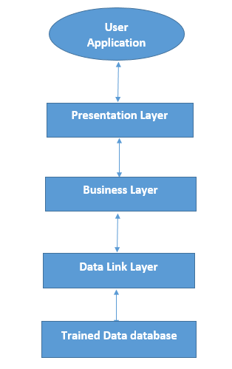

2.3 Dynamic Model: Sequence Diagrams

The sequence diagram show the interactions between objects in the sequential order that those interactions occur. It is an interaction diagram that shows how processes operate with one another and in what order. It show the task sequence of the system shows how entities exchanges messages among one another. It also shows the time of each message.
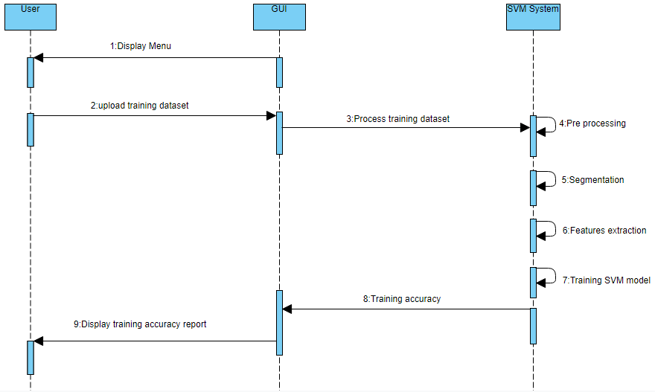
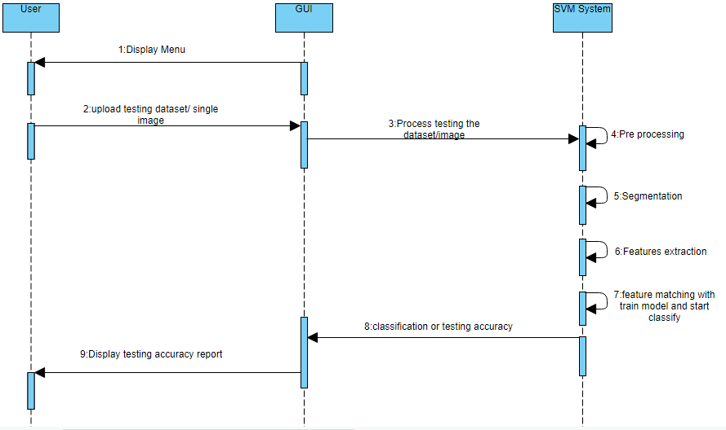

2.4 Object Model/Logical Model: Class Diagram
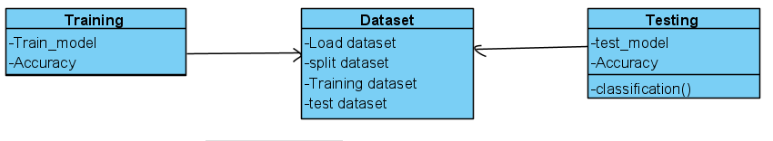
2.5 Graphical User Interface

CHAPTER 3
Development

Introduction
In this chapter we describe the methodology and development of the project. We discuss in this project about dataset also. Architecture diagram for this process is given below.
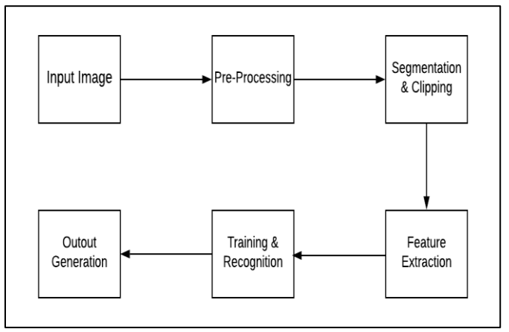

3.2 Dataset
The dataset that is used in this proposed system project is the Plant Village dataset and it was downloaded from the Kaggle website; the dataset consisted of images of diseased and healthy plant leaf images. Upon exploration, we found that the dataset did not have any missing values. The dataset was further explored to understand the various spices and diseases of plant leaf. The dataset consisted of 14 different plant varieties. The training dataset has a total of 54305 images in total. We just used two plant varieties Apple and Corn.

Apple Diseases: apple leaves have three main diseases which affect most.
- Apple scab
- Apple black rot
- Apple cedar apple rust
Corn Diseases: corn leaves have three main diseases which affect most.
- Corn cercospora leaf spot gray leaf spot
- Corn common rust
- Corn northern leaf blight
Sample images of all 8 classes (6 disease class of apple and corn leaves, 2 healthy class of apple and corn leaves) are shown below from figure 1-8.

Corn northern blight Corn leaf spot gray

Corn common rust Corn healthy

Apple black Rot Apple Ceder

Apple Scab Apple healthy

3.3 Features Extraction
This is the very most important part image classification. Before training the model our main task is to extract features of the dataset. Then we use these features to train the model for classification. Following are techniques to extract features from dataset.
- Local binary pattern
- Histogram Oriented Gradient
And many more techniques are used for Features extraction.

3.3.1 Local Binary Pattern Technique

Local Binary Pattern (LBP) is a simple yet very efficient texture operator which labels the pixels of an image by thresholding the neighborhood of each pixel and considers the result as a binary number. It was first described in 1994 (LBP) and has since been found to be a powerful feature for texture classification. It has further been determined that when LBP is combined with histograms of oriented gradients (HOG) descriptor, it improves the detection performance considerably on some datasets. Using the LBP combined with histograms we can represent the face images with a simple data vector.

3.3.2 Histogram Oriented Gradient
Histogram of Oriented Gradients, also known as HOG, is a feature descriptor like the Canny Edge Detector, SIFT (Scale Invariant and Feature Transform). It is used in computer vision and image processing for the purpose of object detection. The technique counts occurrences of gradient orientation in the localized portion of an image. This method is quite similar to Edge Orientation Histograms and Scale Invariant a Feature Transformation (SIFT). The HOG descriptor focuses on the structure or the shape of an object. It is better than any edge descriptor as it uses magnitude as well as angle of the gradient to compute the features. For the regions of the image it generates histograms using the magnitude and orientations of the gradient.

3.3.3 Gray level co-occurrence matrix (GLcM)
A statistical method of examining texture that considers the spatial relationship of pixels is the gray-level co-occurrence matrix (GLCM), also known as the gray-level spatial dependence matrix. The GLCM functions characterize the texture of an image by calculating how often pairs of pixel with specific values and in a specified spatial relationship occur in an image, creating a GLCM, and then extracting statistical measures from this matrix. (The texture filter functions, described in Calculate Statistical Measures of Texture cannot provide information about shape, that is, the spatial relationships of pixels in an image.) . By using this technique we find contrast, correlation, energy and homogeneity features of dataset images. For this project we are using HOG features extraction technique. We apply this technique on dataset and get the features vector.

Classification Algorithm
After the process feature extraction we pass the features in training process using Sequential deep learning model.

Sequential Architecture Deep Learning Model
Deep Learning

Deep learning, a category of machine learning algorithms which uses various layers to do the extraction of higher level from the raw input. Deep learning is a machine learning method that instruct a computer to do filtration of inputs across the layers Deep learning illustrates the way human brain does the filtration of information. Many deep learning techniques utilizes the neural network architectures. The term “deep” cite to the various hidden layers present inside neural network. In contrast to this conventional neural network that consists of 2-3 hidden layers, the deep neural networks can have as much as one hundred and fifty.

Convolutional Neural Network

One variant of deep neural networks is called as convolutional neural networks (CNN). A CNN combines well-read features with input data, and then it uses 2D convolutional layers, and hence makes this architecture more suitable for processing 2D data, like images. CNNs abolish the demand for manual feature removal and extraction for the classification of the images. The CNN model of its own extracts features straight from images. The features that are extracted aren’t pre-trained; they are well-read while the network is trained on few groups of images. The Convolutional Neural Network (CNN) model has numerous of layers which execute the processing of image in convolutional layers include- Input layer, Output Layer, Convo Layer, , Fully, Soft-max layer, Connected layer, Pooling Layer

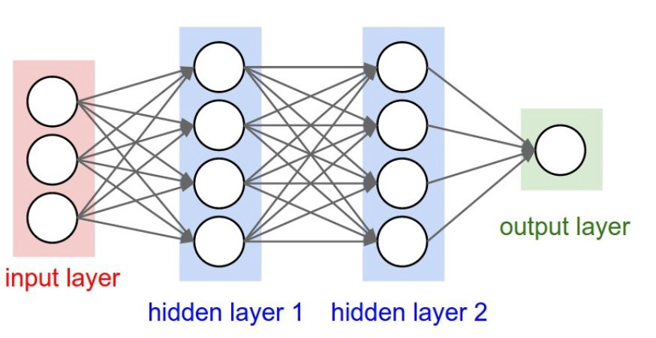

Figure: Sequential model Architecture

Training
Step 1:- Import the required libraries
Here we will be making use of the Keras library for creating our model and training it. We also use Matplotlib and Seaborn for visualizing our dataset to gain a better understanding of the images we are going to be handling. Another important library to handle image data is Opencv.
Step 2:- Loading the data
Next, let’s define the path to our data. Let’s define a function called get_data() that makes it easier for us to create our train and validation dataset. We define the eight labels of eight classes that we will use. We use the Opencv imread function to read the images in the RGB format and resize the images to our desired width and height in this case both being 224.
Step 3:- Visualize the data
Let’s visualize our data and see what exactly we are working with. We use seaborn to plot the number of images in both the classes and you can see what the output looks like.
Step 4:- Preprocess the dataset
Step 5:- Define the Model
Let’s define a simple CNN model with 3 Convolutional layers followed by max-pooling layers. A dropout layer is added after the 3rd maxpool operation to avoid over fitting. We use google colab GPU for training our model. We train our model on 50 epochs. Our training accuracy is 99 percent & validation accuracy is 81 percent. Training and Validation accuracies graph are shown below
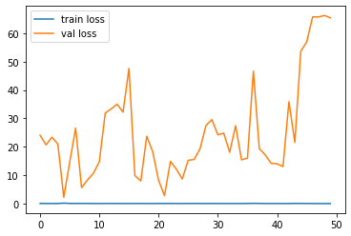
Figure: Training and validation loss

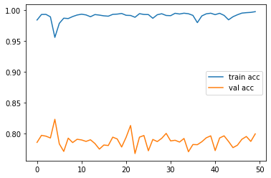
Figure: Training and Validation accuracies

Testing
After training the model we test the model on test dataset. We also test the model using single image and get the accurate result. Confusion matrix

Graphical User Interface
We design Graphical user interface on pycharm by using TkInter python library.

Uploading Image
Main Window

Uploaded image view

Diseases detection window

REFERENCES

[1] | Jiayue Zhao, Jianhua Qu, “A Detection Method for Tomato Fruit Common Physiological Diseases Based on YOLOv2 “Proceeding of the 10th International Conference on Information Technology in Medicine and Education”, Qingdao, China, China, 2019
[2] | Robert G. de Luna, Elmer P. Dadios, Argel A. Bandala, “Automated Image Capturing System for Deep Learning-based Tomato Plant Leaf Disease Detection and Recognition” Proceeding of the IEEE Region 10 Conference, Jeju, South Korea, 2018, pp 1414-1419.
[3] | Militante, S. V., Gerardo, B. D., & Dionisio, N. V. (2019, October). Plant leaf detection and disease recognition using deep learning. In 2019 IEEE Eurasia conference on IOT, communication and engineering (ECICE) (pp. 579-582). IEEE.
[4] | Jasim, M. A., & Al-Tuwaijari, J. M. (2020, April). Plant leaf diseases detection and classification using image processing and deep learning techniques. In 2020 International Conference on Computer Science and Software Engineering (CSASE) (pp. 259-265). IEEE.
[5] | https://www.kaggle.com/datasets/emmarex/plantdisease

